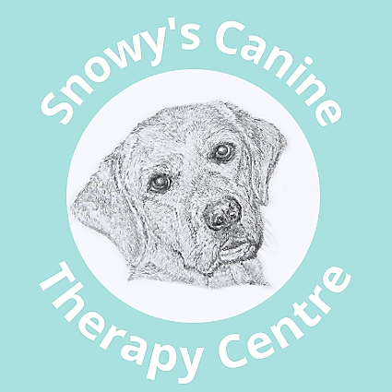
Snowy’s Canine Therapy Centre Limited
The Stables
Tilden Chapel Lane
Smarden
Kent
TN27 8QN
Tel: 01233 434068 / 07747 620625
Email: info@kentcaninetherapycentre.co.uk
Website: www.kentcaninetherapycentre.co.uk

REQUEST FOR VETERINARY CONSENT

DETAILS OF OWNER
Name: Home Tel:
Address: Mobile
Email:

DETAILS OF DOG
Dog’s Name:
Breed: Colour: DOB:
Sex: Neutered: Insured:
Insurance Company Policy Number:
Vaccination due date: Last wormed:

VETERINARY DETAILS
Practice Name & Address:
Tel: Fax: Email:
Veterinary Surgeon:
Reason for Treatment:
Veterinary Diagnosis:
Details of current medication:

Summary of dog’s injury/condition, areas of concern, pre-existing conditions:

Temperament or other information that you feel the Therapy Centre should be aware of:

Please confirm that Veterinary Consent is given for the above dog to attend Snowy’s Canine Therapy Centre to undertake one or all the below treatments with our qualified therapists.

Veterinary Physiotherapy YES / NO

Electrophysical agents; LASER, INDIBA and PMFT YES/NO

Hydrotherapy either in the pool or aquatic treadmill? YES / NO

Do you give consent for Myotherapy Massage? YES / NO

Subject to consent, please indicate how you would like to receive the subsequent treatment report:
Written report: YES / NO Verbal Report: YES / NO Email Report: YES / NO

Signed: M.R.C.V.S. Date:
(Veterinary Surgeon)
Print Name:
Practice Stamp:

Please return this completed form to: info@kentcaninetherapycentre.co.uk

